Dis-ME-Cylinder seal of Hashamer, ensi of the city of Ishkun-Su’en (ca 2100 BCE). BM 59126.

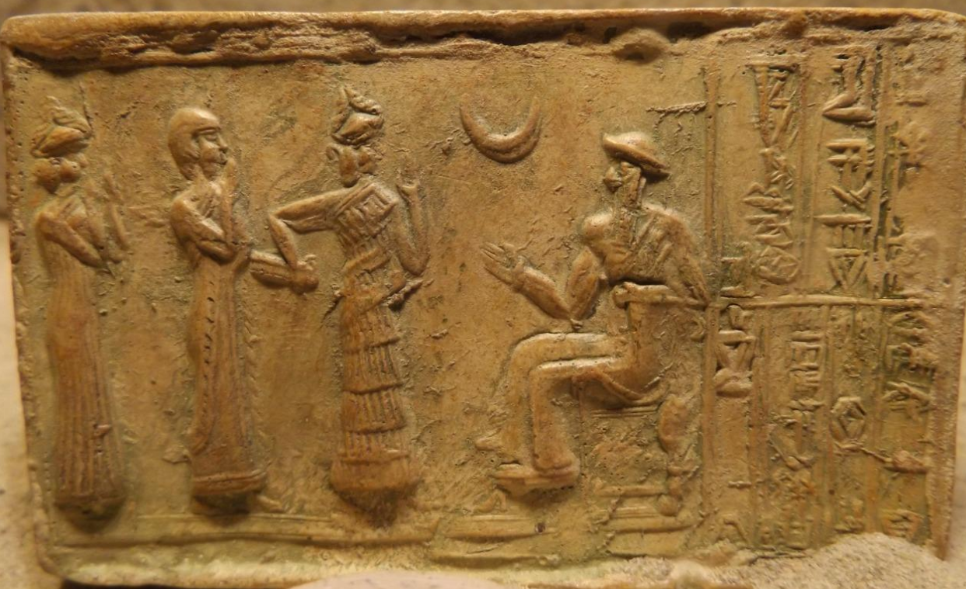

Fig. 1. ME-Cylinder seal impression of Hashamer, ensi of the city of Ishkun-Sîn, Babylon (ca 2100 BCE). BM 59126.

Fig. 1.  Seal of Khashkhamer, governor of Ishkun Sin during the reign of Ur-Namma (end of the 22nd century b . c . ). WA.89126.  British Museum (Matthiae 2000: 61). 
                

**Fig. 2.** ME-Cylinder seal impression. Fig. 3. Greenstone cylinder seal of Hashamer, ensi of the city of Ishkun-Sîn, Babylon (ca 2100 BCE). BM 59126.

**Case no.: 2**

**Accession Number:**

**Formal Label:** ME-Cylinder seal impression of Hashamer, ensi of the city of Ishkun-Sîn, Babylon (ca 2100 BCE). BM 59126.

**Display Description:** Cylinder seal of Hashamer, ensi of the city of Ishkun-Su’en (ca 2100 BCE). This cylinder seal dedication reads, “[To] Ur-Nammu, the mighty hero, king of Ur, [by] Hashamer, the ensi of the city of Ishkun-Sîn, his servant.” Hashamer is being led by a lamma or minor goddess to the king, Ur-Nammu, who is seated beneath Sîn, the crescent Moon-God, from whom Ur-Nammu alleges that his power originates. Impression from the original green-stone cylinder seal in the British Museum, London.

**LC Classification:** DS72

**Date or Time Horizon:** ca 2100 BCE

**Geographical Area:** city of Ishkun-Sîn, Babylon

**Map, GPS coordinates:** 40° 26' 46" N 79° 58' 56" W; 32.46819 44.55019.

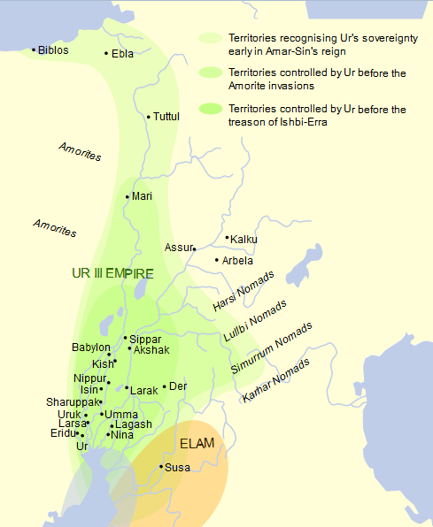

Fig. 2. Map of Ur III empire, ca 2100 BCE, based on Garelli 1974. From https://upload.wikimedia.org/wikipedia/commons/thumb/e/e8/Map_of_Ur_III.svg/1200px-Map_of_Ur_III.svg.png.

**Cultural Affiliation:** Neo-Sumerian

**Medium:** Impression of original green-stone cylinder seal.

**Dimensions:** Impression, W 9 cm; 3-1/2 in; H 5.5 cm; 2-1/4 in

**Weight: n/a**

**Condition:** Impression from the original green-stone cylinder seal, ME 89126, in the British Museum, London.

**Provenance:** Obtained at Babylon some time before 1820 CE by John Hine and presented to the British Museum by C.D. Cobham by 1880 CE; then British Museum, ME 89126, Room 56, Early Mesopotamia, case 20.

**Discussion:**

Ur-Nammu, the founder of the 3rd Ur dynasty in s Mesopotamia 2047-2030 BCE, initiated a renaissance in art, building projects and a legal code.

He is seated on a throne as Hashamer is being led to him by a lamma or minor goddess, who is identified by a horned headdress and her distinctively pleated dress. Another minor goddess to the left (also with a horned headdress but without the pleated dress) has her hands raised in supplication.

Nanna-Sîn was the syncretistic god of the Moon in Mesopotamian mythology. Nanna was a Sumerian deity, the son of Enlil and Ninlil, who became associated with the Semitic Sîn. Nanna's chief sanctuary was at Ur I the south and was named E-gish-shir-gal ("house of the great light"). Sîn’s major sanctuary was at Harran in the north and was named E-khul-khul ("house of joys"). From these two important cult centers the cult of the syncretized moon-god, Nanna-Sîn, diffused to many other centers, so that temples to him are found in all the large cities of Babylonia and Assyria, thereby expanding the reach of Mesopotamian culture, theology and political power.

In this cylinder seal impression, the crescent Moon, the symbol of Nanna-Sîn, is positioned directly above Ur-Nammu’s right hand, the hand of power and justice. Nanna-Sîn was the pre-eminent god who was venerated throughout Mesopotamia and whose theological cult center and Ur-Nammu’s political center was Ur, which consolidated the Mesopotamian theocratic hegemony of Ur-Nammu. Thus, the theological centralization of the powers of the universe mirrored the political centralization of powers in the royal household. It led to the establishment of an astrological doctrine of a triad. Nanna-Sîn’s partner was dNin.gal known from an Ugaritic myth as *nkl* (KTU 1.24). dNin.gal bore him Utu/Shamash (“the Sun God”) and Inanna/Ishtar (“the planet Venus Goddess”), which constituted the theological triad of Nanna-Sîn and his two children. Consequently, astrology, which measured the Moon’s phases (represented by the number 30, the average number of days in a lunar month from the very first visible crescent to the last), the Moon’s interaction with the Sun in eclipses and the motion of Venus traversing the heavens became important factors in Ur-Nammu’s governance of events on Earth, from politics to medicine.

**References:**

Garelli, Paul. 1974. *El Imperio de Ur y su herencia», en El Próximo Oriente asiático*. Barcelona: Labor.

KTU = Dietrich, Manfried; Oswald Loretz; and Joaquín Sanmartín. 2013*. Die* ***k****eilalphabetischen* ***T****exte aus* ***U****garit, Ras Ibn Hani und anderen Orten = The Cuneiform alphabetic texts from Ugarit, Ras Ibn Hani and other places*. Münster: Ugarit-Verlag.

Oxford University, The Electronic Text Corpus of Sumerian Literature, [Enlil and Ninlil: Translation](http://t.umblr.com/redirect?z=http%3A%2F%2Fetcsl.orinst.ox.ac.uk%2Fsection1%2Ftr121.htm&t=MmQ5MWU1NjI1YWQ3NTNkZDlmZjE1MmU1NDE5YTgyYWUzNzg5NjE0OCxiRklYZGMxWQ%3D%3D&b=t%3AQxb9iKB7nKnDBYlR6qHdkw&p=http%3A%2F%2Fgoldisblood.net%2Fpost%2F101875929568%2Fgod-of-the-moon-sin-or-nanna-in-mesopotamian&m=1), <http://etcsl.orinst.ox.ac.uk>.